FOR IMMEDIATE RELEASE: 31 December 2015

GALERIE DE WITTE VOET PRESENTS TILMANN MEYER-FAJE’S “PREFABRICATED CITY”

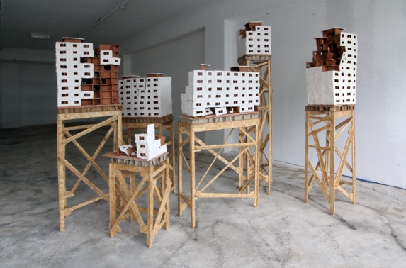 | TILMANN MEYER-FAJE: “PREFABRICATED CITY”  Galerie De Witte Voet  www.galeriedewittevoet.nl  Kerkstraat 135, Amsterdam  GALLERY EXHIBITION:  23 January - 20 February 2016  OPENING:  Saturday 23 January 16:00 – 18:00  with introduction at 16:00 by Ranti Tjan,  director of the European Ceramic Work Centre  PLUS SPECIAL Tilmann Meyer-Faje Solo
“Prefabricated City” 180 cm x 230 cm x 168 cm, clay and wood  FOTO: Tilmann Meyer-Faje | ROTTERDAM CONTEMPORARY ART FAIR  10-14 FEBRUARY (gallery temporarily closed)
Galerie De Witte Voet is pleased to announce “Prefabricated City” a solo exhibition of Tilmann Meyer-Faje’s ceramic constructions, on view at Kerkstraat 135 in Amsterdam, 23 January through 20 February. Ranti Tjan, director of the European Ceramic Work Centre, will introduce the exhibition at the opening on Saturday, 23 January at 16:00. The exhibition will move temporarily to the Rotterdam Contemporary Art Fair/Cruise Terminal - Tilmann Meyer-Faje Solo from 10-14 February. During the art fair, Galerie De Witte Voet will be closed. “Prefabricated City” will return to the gallery in Amsterdam for the final week of the exhibition.

This exhibition is the first ceramic retrospective of Tilmann Meyer-Faje’s work and includes earlier sculptures as well as the recent installation,“Prefabricated City,” made at the Kosice Artist Residency in Slovakia, which gives the title to this show.

Tilmann’s ceramic sculptures are purposefully imperfect replicas of existing constructions. Failed Utopian dreams. One of his major themes is Soviet architecture. Built quickly, his sculptures are often fragile, on the brink of collapse, monuments that point to the inevitable demise of overly controlling systems. Only the materials can be obeyed, the dynamism of the clay, like the hearts of a people, too unruly to be tamed completely.

The work is both artifact and fiction; the roughness and imperfection of the construction mirroring the socio-political system behind its origin.

"I’m fascinated by the roughness and naivety of these buildings. In communist countries, it could happen that workers received an order to produce shoes one day and the next day they were sent out to pour concrete into molds for prefabricated neighborhoods. You can imagine how the machinery of this construction system led to many accidents and mistakes. When I came to the European Ceramic Work Centre (EKWC) in 2011 for my first residency, I had seen a lot of these buildings, and I had not had any experience yet with clay. A good starting point then was to place myself in the same position of a naive worker, only executing during my residency."

Tilmann sees his work as a research experiment, an opportunity for observation. He has always been interested in irony and the point between theory and experience. Before working with the industrialized urbanization of the Soviet Union, he created live interventions to Dutch city plans from the 60’s and 70’s. One of the most famous of these performances was Buurtkroket, or District Croquette, a snack bike designed as an urban intervention for Museum de Paviljoens in Almere, where he served croquettes made from recipes of the inhabitants.

His interest in public, urban interventions evolved into interactions with materials, where he explores the same themes of failed urban planning, irony, repetition and social experimentation while working with his hands. In recent and future works, he continues his explorations in the tension between construction and decay; the failure of a simulated industrial process and controlled logic. “The trick is to find the point that you are aware of, how far I can go? So you know the edge that you’re on. And you only have the point ok, now it’s done. And there you have to stop. That’s what I am still developing.”

Like the unskilled workers assigned to pour the concrete for those Soviet tower blocks, Tilmann embraces a naivety and unknown in undertaking his tasks in clay (and sometimes wood). “I really believe in repeating things. The more you repeat and work, the more you get a kind of spontaneous feeling. You just discover by doing, you generate knowledge by doing. I’m still doing the same experiments and making observations as in the beginning, but it's getting more sophisticated.”

Tilmann Meyer-Faje was born in 1971 in Oldenburg, Germany. He lives and works in Amsterdam and studied at UVA, Gerrit Rietveld Academie and Sandberg Institute there. He received a grant from Mondriaan Fund for working periods at the European Ceramic Work Centre (EKWC) in 2011, 2013 and 2016. “Prefabricated City” was made possible by Motel Spatie and Stichting Stokroos.

For more information about Tilmann Meyer-Faje, please visit his website: www.tilmann.nl
For more information about the “Prefabricated City” exhibition and Galerie De Witte Voet, visit www.galeriedewittevoet or contact info@galeriedewittevoet.nl.
###

IMAGES: For high-resolution images, please contact info@galeriedewittevoet.nl.
PRESS CONTACT: Annemie Boissevain
PUBLIC INFORMATION:
Galerie De Witte Voet, Kerkstraat 135, 1017GE Amsterdam
The public may visit www.galeriedewittevoet.nl for additional information.
OPEN HOURS: Noon–6pm Thursday through Saturday; 2-5pm First Sunday monthly.
Or by advance appointment.
© Robbyn McGill

