FOR IMMEDIATE RELEASE: 17 November 2015

GALERIE DE WITTE VOET PRESENTS ÁNGEL GARRAZA’S “INTERNAL CAUSES”

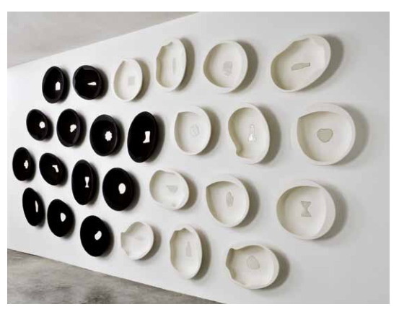 | ÁNGEL GARRAZA: “INTERNAL CAUSES”  Galerie De Witte Voet  www.galeriedewittevoet.nl  Kerkstraat 135, Amsterdam  Exhibition:  Friday 27 November 2015 -16 January 2016  Opening (with introduction by the artist):  Friday 27 November, 5-7:30 p.m.  (Gallery closed 24 December – 3 January)

Galerie De Witte Voet is pleased to announce “Internal Causes,” an exhibition of innovative sculptor Ángel Garraza’s ceramic work, on view at Kerkstraat 135 in Amsterdam, 27 November through 16 January. The artist will introduce the exhibition at the opening from 5-7:30 p.m. on Friday, 27 November through an English translator.

“Internal Causes” includes pieces and installations from two series of Garraza’s work, “Things and Causes” (2008-2014) and “Illuminated Interiors” (2005-2013). The selection in this exhibition is representative of the transitional developments in Garraza’s oeuvre as well as the ongoing dichotomy in all the work; hermetic and organic shapes, flawlessly refined, contrast the light and dark, inside and outside, magic and natural, hidden and superficial. Opposing twos create one, exploring relationship, human nature and its fragile identities. It’s a strong analogy: an artist sculpting to be sculpted internally and externally.

“With the passing of time I have simplified and perfected the processes, I have professionalized them. I try to dominate the medium to the highest level possible so that the work flows as naturally as possible, expressed without leaving a trace. That is to say, that the objects are impeccable, that they appear natural, that they are born spontaneously, that they are not manipulated. I simplify.”

In all of Garraza’s work, time is the key, a powerful force that shapes the material, metaphorically and literally. Eluding the desire to capture (or mold) that which is eternally changing, time becomes a personal code of incarnated memory and memories.
“Through my work I attempt to speak of what I know, but not to understand it, which, in a certain way, is Life: the mechanisms that make us sensitive towards pain, love, affection, things that are well known, but not necessarily understood. Often, without realizing it, one continues to repeat oneself and does not reach this objective. This is surely the driving force of art, that one never manages to give a satisfactory account of oneself.”

Born 1950 in Allo, Navarra, Angel Garraza has exhibited extensively throughout Spain and in many other European countries, including Germany, France, Finland, Italy, Portugal, Denmark, Holland, Switzerland, and Belgium. He has also exhibited in Tokyo, Kyoto, Seoul and Taipei.

He has previously shown in solo exhibitions at Galerie De Witte Voet in 2004, 2007 and 2009 at Art Amsterdam and group exhibitions in 2000, 2005, 2010 and 2015.

Other solo exhibitions have taken place at: Sala CIA Luzán in Zaragoza, Spain (2008); Jordana Espacio in Madrid, Spain (2010); Factoría Compostela in A Coruña, Spain (2011); Centre Cèramique Contemporaine La Borne in France (2011) and Espacio Marzana in Bilbao, Spain (2012).

His work is held by many major international museums and in public and private collections.
For more information about Ángel Garraza, please visit his website:

http://www.angelgarraza.es. For more information about the “Internal Causes” exhibition and Galerie De Witte Voet, visit www.galeriedewittevoet or contact info@galeriedewittevoet.nl.

###

IMAGES: For high-resolution images, please contact info@galeriedewittevoet.nl.
PRESS CONTACT: Annemie Boissevain

PUBLIC INFORMATION:
Galerie De Witte Voet, Kerkstraat 135, 1017GE Amsterdam
The public may visit www.galeriedewittevoet.nl for additional information.
OPEN HOURS: Noon–6pm Thursday through Saturday; 2-5pm First Sunday monthly.
Or by advance appointment.

© Robbyn McGill

Nota Bene
Het ziet er wel heel professioneel uit met deze mededelingen voor de pers.
Dat voldoet nu alleen voor de week- en dagbladen. Die moeten dan een aparte mail ontvangen.

Public Information is ook goed als tekst voor de uitnodiging

